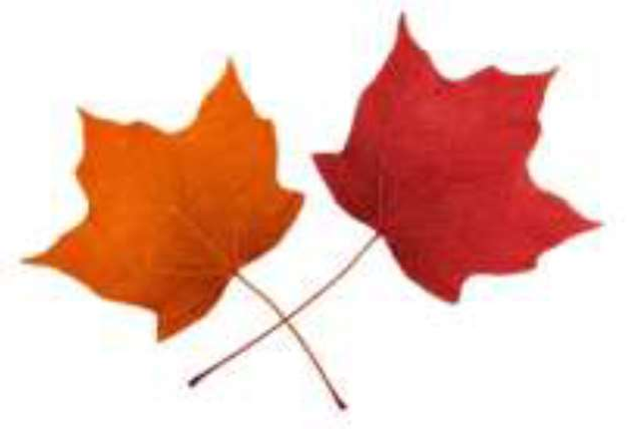

ENDLESS MOUNTAINS MAPLE FESTIVAL
April 25 & 26 2026

Maple Syrup & Confections Contest Entry Form

Contact Name:

Address:

City, State: Zip:

Phone: Email:

Place a check mark beside the maple categories you are entering.

Pure Maple Syrup, Light/Golden

Pure Maple Syrup, Medium/Amber

Pure Maple Syrup, Dark

Maple Candy

Maple Cream

MAPLE FESTIVAL MAPLE PRODUCTS UPDATED RULES AND PREMIUM
PAYOUTS FOR 2026

*MAPLE JUDING WILL TAKE PLACE ON FRIDAY APRIL 24TH 2026*

PRODUCTS WILL NEED TO BE DROPED OF AT THE FAIR OFFICE BY 5PM THURSDAY APRIL 24TH

Classes:
Maple Syrup (half pint or larger size, approx. 8oz.)
(Golden, Amber or Dark)

Maple Candy (3 pieces, approximately 3 oz.)

Maple Cream

Syrup to be judged on Flavor, Color, Density and Clarity. The grade must be labeled on container (Golden, Amber or Dark)

Candy to be judged on appearance, texture and flavor.

Cream to be judged on appearance, texture and flavor.

Premium PAYOUT

Syrup:
1st- $25 2nd- $15 3rd-$10

Candy & Cream:
1st- $25 2nd- $15 3rd- $10

