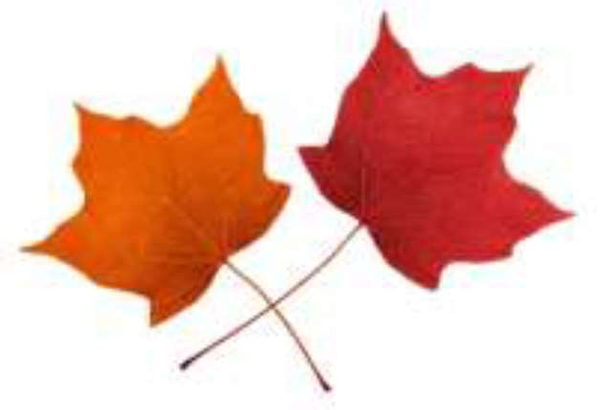

ENDLESS MOUNTAINS MAPLE FESTIVAL

April 26 & 27 2025

Maple Syrup & Confections Contest Entry Form





Contact Name:

Address:

City, State: Zip:

Phone: Email:

Place a check mark beside the maple categories you are entering.

Pure Maple Syrup, **Light/Golden**

Pure Maple Syrup, **Medium/Amber**

Pure Maple Syrup, **Dark**

**Maple Candy**

**Maple Cream**

**MAPLE FESTIVAL MAPLE PRODUCTS UPDATED RULES AND PREMIUM**

**PAYOUTS FOR 2025**

**\*NEW THIS YEAR MAPLE JUDING WILL TAKE PLACE ON FRIDAY APRIL 25TH 2025\***

**PRODUCTS WILL NEED TO BE DROPED OF AT THE FAIR OFFICE BY 5PM THURSDAY APRIL 24TH**

**Classes:**

**Maple Syrup (half pint or larger size, approx. 8oz.)**

(Golden, Amber or Dark)

**Maple Candy (3 pieces, approximately 3 oz.)**

**Maple Cream**

Syrup to be judged on Flavor, Color, Density and Clarity. The grade must be labeled on container (Golden, Amber or Dark)

Candy to be judged on appearance, texture and flavor.

Cream to be judged on appearance, texture and flavor.

**Premium PAYOUT**

**Syrup:**

**1st- $25 2nd- $15 3rd-$10**

**Candy & Cream:**

**1st- $25 2nd- $15 3rd- $10**