Macaroni and Cheese Cook-Off
At the
39th Endless Mountains Maple Festival

Are you a local restaurant owner who just happens to make the BEST Mac N' Cheese EVER? Come out and compete for the official title!
We are offering two categories to enter in:
Traditional or Creative
Prizes for each category will be awarded!
1st Place- Bigfoot Radio Promotions and an awesome plaque!
2nd Place- Promotions and a framed certificate
3rd Place- Promotions and a framed certificate
Registration deadline is April 16th, 2021
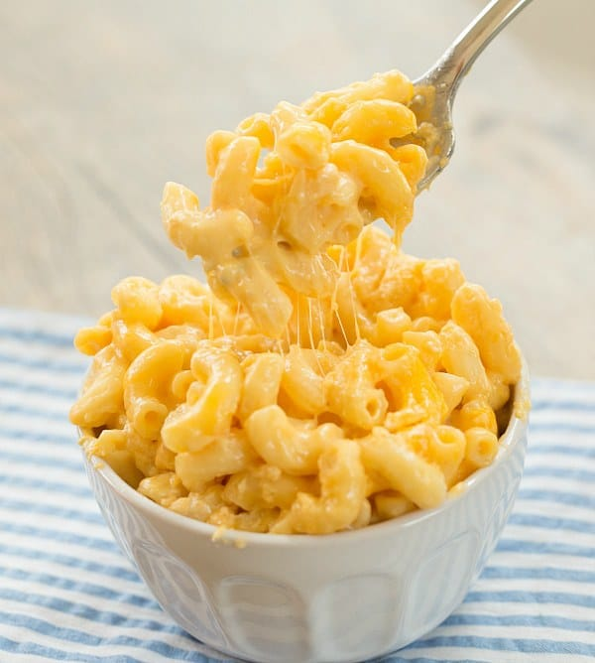

Rules
- Upon arrival, the team captain must check-in with the Committee representatives for their area assignment. At that time, we will provide you with any new or additional information concerning the cook-off.
- You must enter a crockpot with at least 6 cups of Macaroni & Cheese. Public will be purchasing tickets for tasting.
- Due to Allergies, an ingredient list is required for your Macaroni & Cheese at entry.
- Macaroni & Cheese must be prepared in advance.
- Teams must bring their own crockpot, cooking utensils, extension cord, table cover, decorations (if you want), etc.
- Set-up/Booth decorating can begin as early as 9 am.
- Each team is expected to maintain a clean and sanitary area.
- Judging will be at noon and samples will be distributed at 12:30pm.
- Judges will announce the selected winning Macaroni & Cheese dish based on aroma, appearance, taste/flavor, and texture.
- The selected winner will be announced promptly
- It is the responsibility of the contestant to clean-up the crockpot and all utensils after the judging.
- Areas must be cleaned up at the end of the event. Alparon Park would appreciate your help in keeping the event site beautiful. Contestants are responsible for cleaning up any trash that is within your booth space and deliver all garbage to the available collection area.
- Expenses: Each contestant/team will receive 2- free admission into the Maple Festival Sunday, April 26th and should not expect any other compensation for expenses.
There will be 2 Categories
- Traditional- Homestyle, Cheeses, and one type of pasta
- Creative Flavors- Combined flavors, unusual add-ins (Bacon, Maple,etc.), use your imagination!
**A prize will also be given for best overall booth appearance which includes the booth, staff, and presentation. **

~Paneled judging will be done by carefully selected judges who will rate your Mac & Cheese on AROMA, APPEARANCE, TASTE/FLAVOR, AND TEXTURE~
- Entry Forms can be obtained in the Alparon Community Park office, online at maplefestivalpa.com or by e-mailing info@maplefestivalpa.com
- Contestants can be a team or a one-person team.
- Event staff will be on the premises to assist with check-in and space allocation.
- Electricity, table, and chairs will be provided, but bring your own crockpot, utensils for cooking/serving, and extension cord.
- Arrival time, parking instructions, and other details will be e-mailed to you shortly before the event.
Thank You!

